**How Animals Adapt to Their Environments – Examples and Evolution**[1]

**Cephalopods**

Cephalopods include octopus, squid and cuttlefish. To learn about cephalopod camouflage, view the video, “Octopus Camouflage” (<https://www.youtube.com/watch?v=eS-USrwuUfA>).

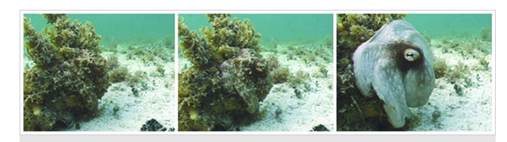

**1a.** Read the definitions in the table below. Then, watch the video, “Cephalopod Camouflage” (<https://tinyurl.com/cephcamoflage>), and look for and describe an example of each phenomenon listed in this table.

|  |  |  |
| --- | --- | --- |
| **Definition** | **An Example from the Videos and**  **How the Example Fits the Definition** | **Is this example an adaptation? Explain why or why not.** |
| **Camouflage** means that an animal has an appearance (color, pattern, and/or shape) that helps them blend into the background. |  |  |
| **Mimicry** means that an animal looks like another object or species. |  |  |
| **Phenotypic plasticity** means that a single genetic makeup can produce different phenotypes in different environments. Phenotypes are the physical and physiological characteristics of an organism. |  |  |

**1b**. An **adaptation** is a characteristic that helps an organism to survive and reproduce in its environment. Complete the third column of the table above.

**Peppered Moth Caterpillars and Adults**

The color of most peppered moth caterpillars matches the branches in their environment (see photos below). If there is a mismatch, these caterpillars can change their color to match the branches that they are on, but only when they molt to get bigger. This phenotypic plasticity in body color improves camouflage for these peppered moth caterpillars.

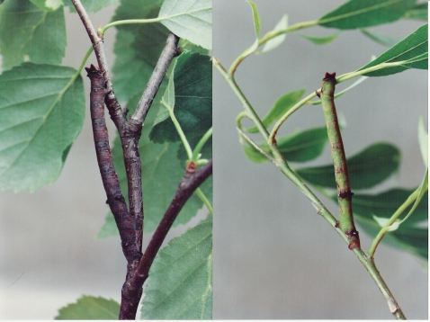

**2.** The birds that eat these caterpillars use vision to find their prey. Explain why the phenotypic plasticity of peppered moth caterpillars is an adaptation. (Hint: See the definitions on page 1.)

Peppered moth caterpillars often rest in a posture that mimics the angle of the branches of the tree they are resting on. Can you find the caterpillar in the photos below?

|  |  |
| --- | --- |
| Figure 1 | Figure 1 |

When these caterpillars adopted a twig-like posture, birds were more likely to attack a twig first, instead of a caterpillar. Birds also took longer to find the caterpillars that adopted a posture that mimicked twigs.

**3.** Explain why mimicry in peppered moth caterpillars is an adaptation.

Both of these photos show the two major forms of adult peppered moths – speckled and dark.

* The photo on the left shows the speckled and dark moths on a tree that was covered with lichen. Lichen-covered trees were common in England in the early 1800s, before industrialization began, and again in the early 2000s, after air pollution was cleaned up.
* The photo on the right shows these moths on a tree that was covered with dark soot. Dark, soot-covered trees were typical in industrial regions of England, approximately 1900-1960.

|  |  |
| --- | --- |
| https://www.ucl.ac.uk/~ucbhdjm/courses/b242/OneGene/pep1.jpg |  |

Can you find the speckled form of the adult peppered moth on the lichen-covered tree trunk

in the photo on the left? Can you find the dark form of the peppered moth on the dark tree trunk in the photo on the right?

Adult peppered moths are active at night. During the day, they rest on tree trunks and branches. Some of these resting peppered moths are eaten by birds. In each environment shown above, predation by birds resulted in higher mortality for the moths that had less effective camouflage in that environment.

**4.** In each photo, circle the form of the peppered moth that would be more obvious to bird predators and, as a result, would have higher mortality in that environment.

The definition of an adaptation on page 1 is incomplete; a complete definition requires one more word. An adaptation is a heritable characteristic that helps an organism to survive and reproduce in its environment. Different alleles of a single gene determine whether a peppered moth is speckled or dark.

**5**. Which form – speckled or dark – is an adaptation for peppered moths in each environment?

|  |  |
| --- | --- |
| Environment | Adaptation in this Environment |
| Lichen-covered tree trunks |  |
| Dark, soot-covered tree trunks |  |

**6.** A gene determines whether a peppered moth is speckled or dark, so an individual peppered moth cannot adapt to changes in its environment by changing from speckled to dark or vice versa. How do you think that populations of peppered moths adapted to the shift from lichen-covered trees to dark, soot-covered trees during industrialization?

This graph shows trends in the percent of peppered moths that were dark in a region in England that industrialized between about 1850 and 1900.

|  |  |
| --- | --- |
|  | The dots indicate data points. The width of the line indicates uncertainty in the estimates. |

**7.** Complete this table.

|  |  |  |
| --- | --- | --- |
| Time Period | Trend in Air Pollution and Tree Trunks | Trend in Percent of Adult Peppered Moths That Were Dark |
| ~1850-1900 | During industrialization, there was more soot in the air, so tree trunks became darker. |  |
| ~1960-2000 | Regulations decreased air pollution, so less soot and more lichen resulted in lighter tree trunks. |  |

**8a.** What is natural selection?

**8b.** Explain how natural selection caused the increase between ~1850 and 1900 in the percent of peppered moths that were dark.

The following paragraphs summarize several important conclusions from the activity so far.

* Phenotypic plasticity allows an individual organism to adapt to different environments during its lifetime.
* Natural selection for an adaptation allows a population of organisms to adapt to different environments. Some adaptations are examples of phenotypic plasticity, while other adaptations are more stable characteristics that are *not* examples of phenotypic plasticity.

**9a.** Give an example of an adaptation that is also an example of phenotypic plasticity.

**9b**. Give an example of an adaptation that is *not* an example of phenotypic plasticity.

**Daphnia (the Water Flea)**

This section describes a study that showed that, when the environment changes, natural

|  |  |
| --- | --- |
| selection can increase phenotypic plasticity. Daphnia are small (1-5 mm) animals that live in ponds and lakes. (See figure.)  **10.** Daphnia are eaten by two major types of predators. These predators have opposite size preferences.   * A very common invertebrate predator can only capture small Daphnia. * Fish predators are more likely to detect and eat larger Daphnia. | Care Guide: Daphnia | Carolina Biological Supply |

Thus, larger size helps Daphnia avoid being eaten by invertebrate predators, but ____________

(larger / smaller)

size helps Daphnia avoid being eaten by fish predators. Therefore, the optimum size for

Daphnia would be _____________ if only invertebrate predators were present in a pond and

(larger / smaller)

smaller if both fish and invertebrate predators were present.

Scientists tested for phenotypic plasticity in the size of Daphnia, depending on whether they developed in water with or without fish smell. To test genetically identical Daphnia that developed in two different conditions, these scientists used the clones of genetically identical Daphnia that result when Daphnia reproduce asexually. The scientists tested for phenotypic plasticity in size for samples of Daphnia taken from the same pond during two different time periods.

|  |  |
| --- | --- |
| **Conditions When**  **Samples of Daphnia Were Taken** | **Results** |
| Invertebrate predators, but no fish.  This sample was taken before this new pond had any fish. | No significant difference in size for newborn Daphnia that developed in water with fish smell vs. without fish smell. |
| Both invertebrate and fish predators.  This sample was taken when this pond was stocked with many fish. Sampling of Daphnia began one year after fish stocking began. | Newborn Daphnia that developed in water with fish smell were significantly smaller than genetically identical newborn Daphnia that developed in water without fish smell. |

**11a.** In the above table, circle the result that is an example of phenotypic plasticity.

**11b.** Explain how natural selection could have caused the change in phenotypic plasticity for the Daphnia in this pond. (Hint: Think about what type of Daphnia were killed by fish predators when the pond was first stocked with many fish.)

This example illustrates that phenotypic plasticity can be an adaptation that can be increased by natural selection. This example and additional data support the conclusion that phenotypic plasticity can be an adaptation that can evolve by natural selection.

1. By Dr. Ingrid Waldron, Department of Biology, University of Pennsylvania, © 2025. This Student Handout and Teacher Notes with instructional suggestions and background biology are available at [http://serendipstudio.org/exchange/bioactivities](http://serendip.brynmawr.edu/exchange/bioactivities)/evoadapt.